**Section02 Extra Info**

**Notes:-**

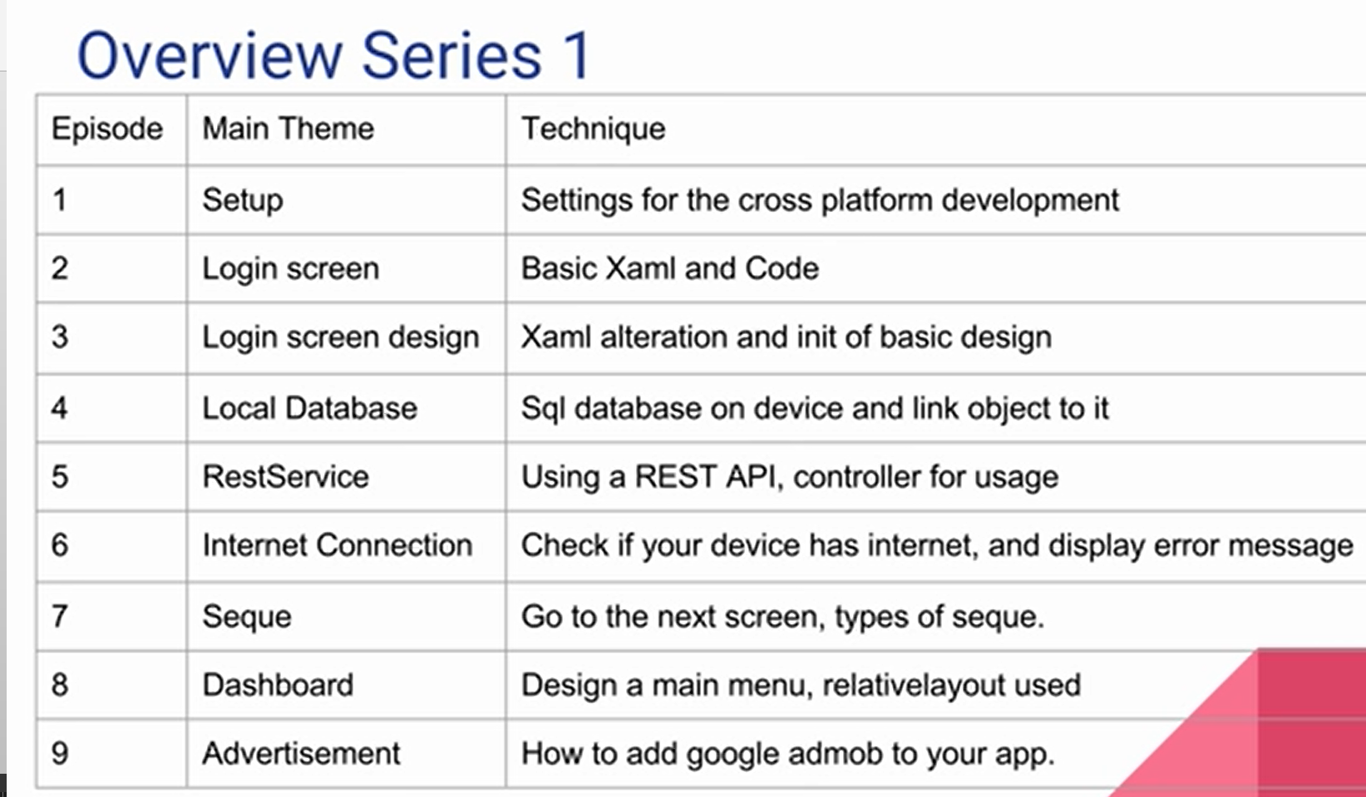

**1-xamarin is built by microsfot that allow to build cross platform app**

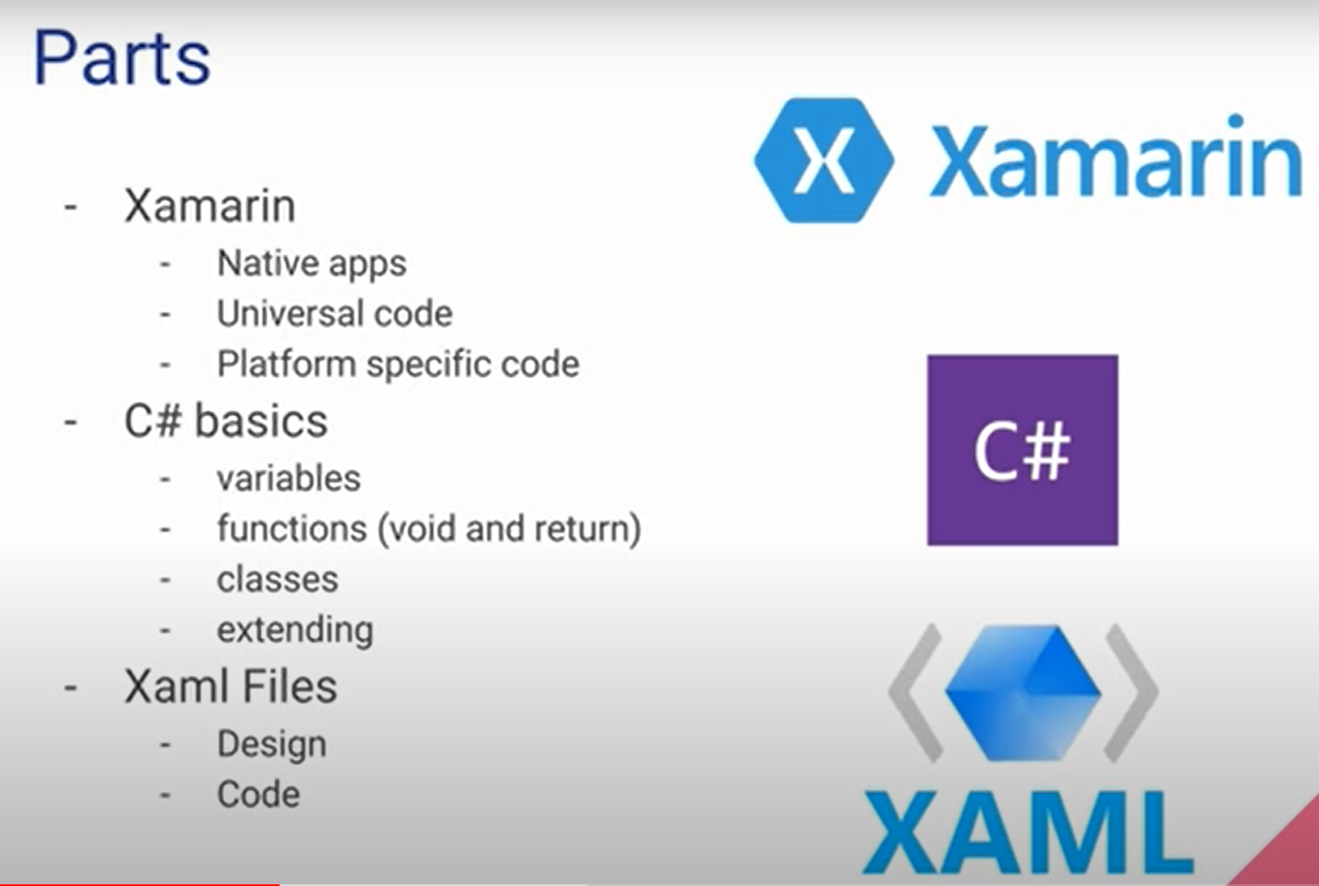

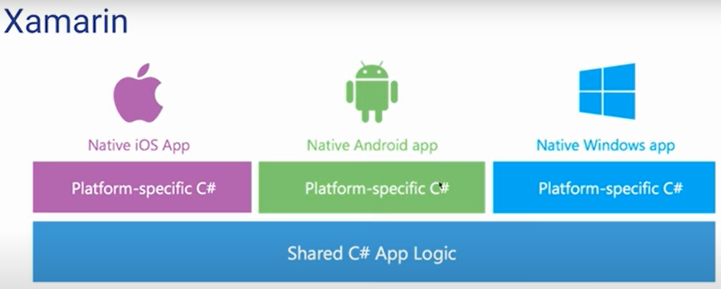

**1-xaml if the markup language that used on the view that split into two parts**

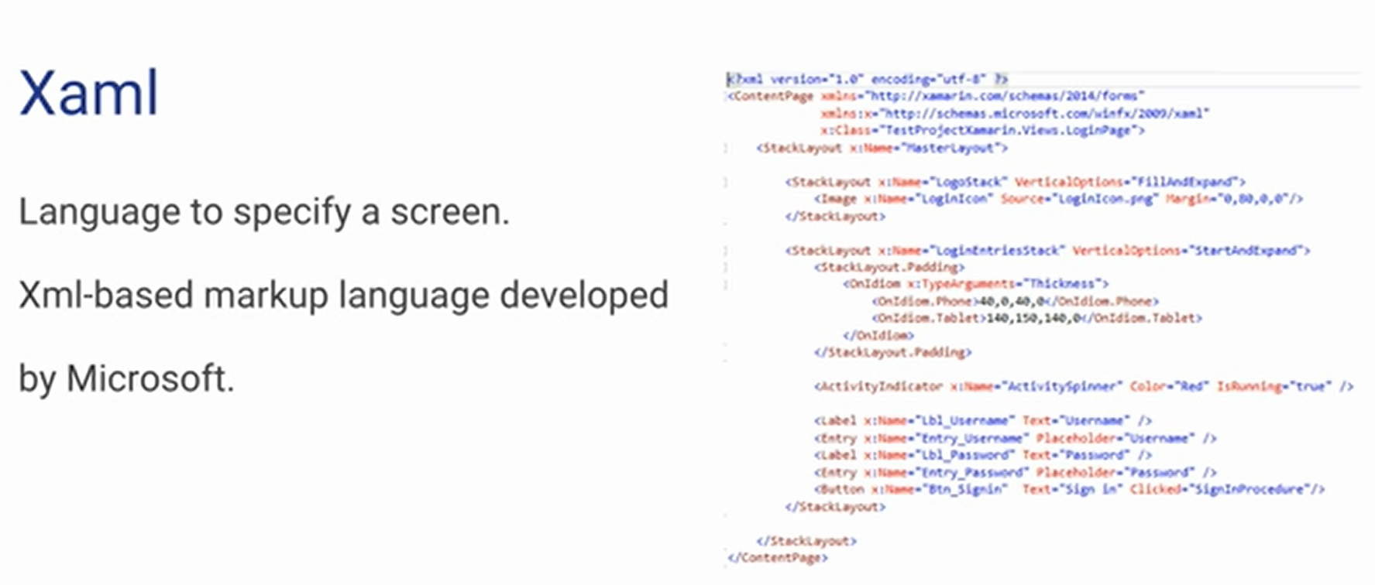

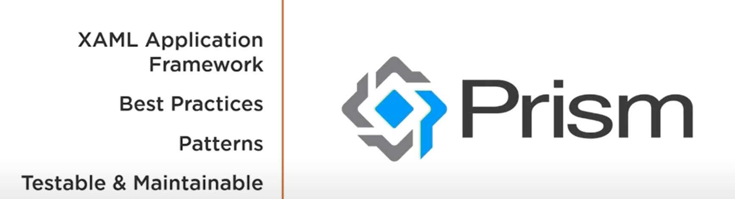

**Xamarin Features:-**

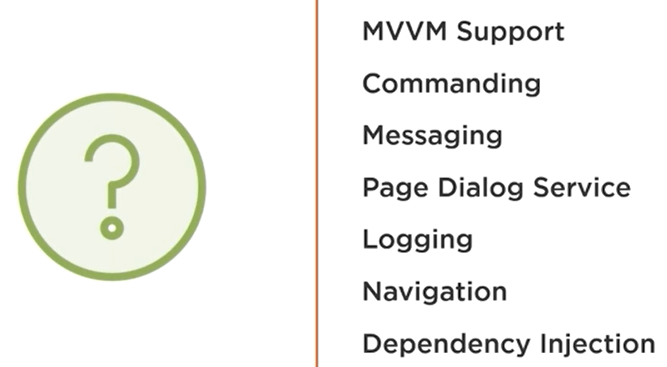

**We see that you can install Prism as extension and create new Prism Form project or install the three nugget packages as below**

**Prism.Core**

**Prism.Form**

**Prism.Utility**

**But if you install Prism as extension and create new Prism form project ,you will see that it will install the prism engine you choose as below (Prism.Dryloc.Forms)**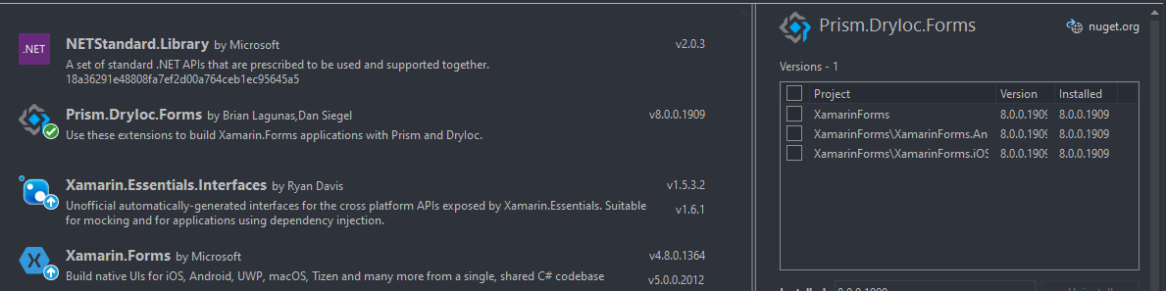

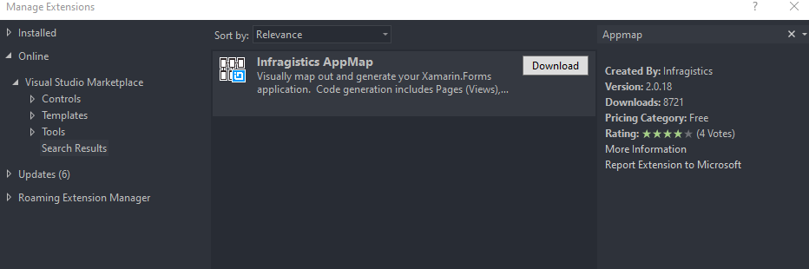

**On the VS 2019 > create new project AppMap(Project xamarin forms)**

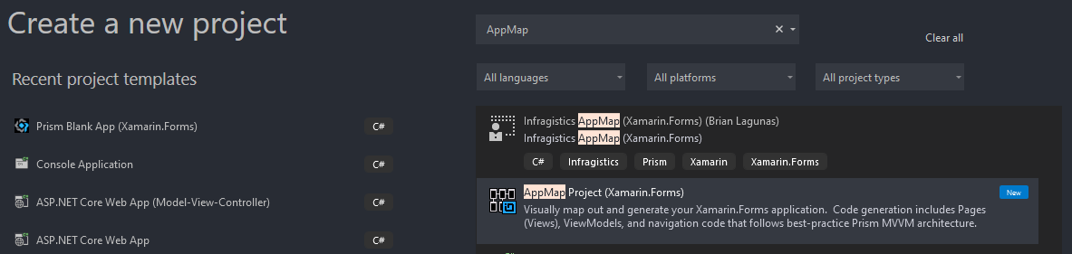

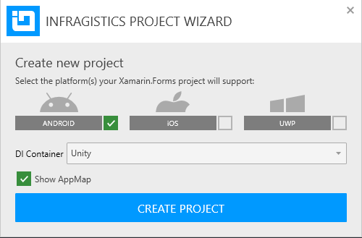

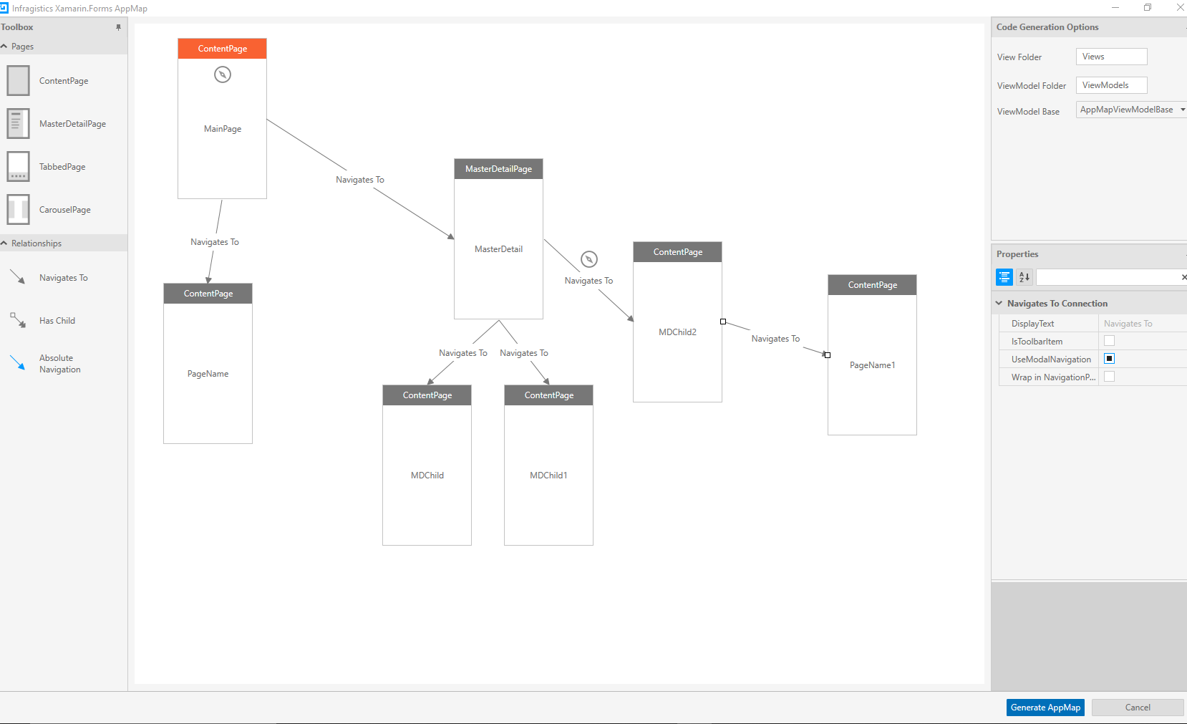

**We choose Content Page as entry page and master detail page that contains child pages**